Your name ___________________________________________ Latin American & Latina/o Art 111
O’Brien

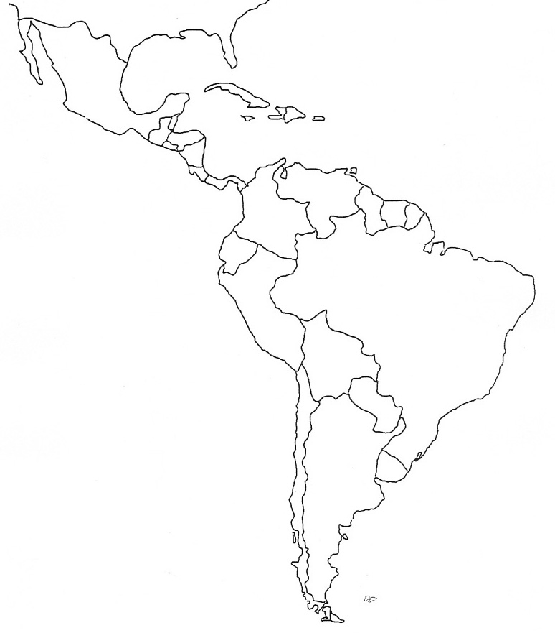

Nations of Latin America Map Quiz: On a separate sheet of paper, list by number, starting with number 1, the names of the countries on this map. Include Cuba, Haiti, Dominican Republic, and Puerto Rico (unincorporated territory of the United States)

